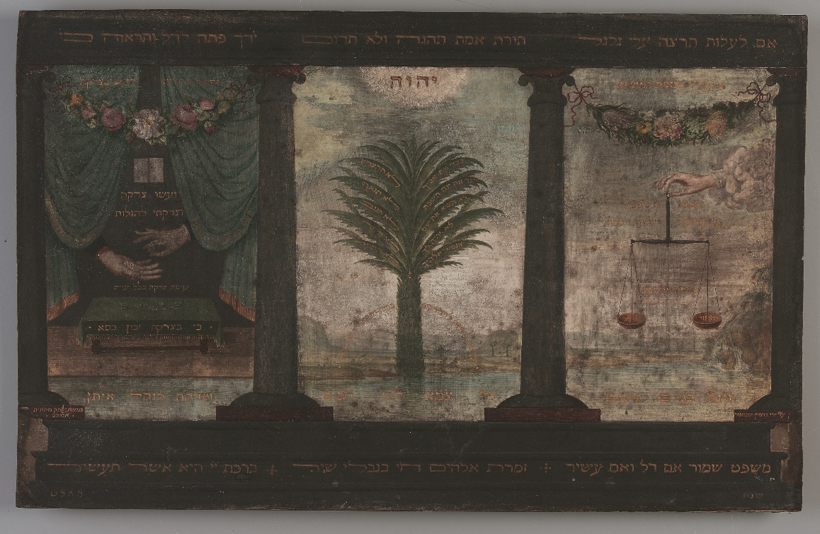
GCSE Mitzvot in Daily Life: Tzedakah (Charity) – Outreach

Summary: Discover where the 613 commandments come from and the different sources of authority. Explore how the commandments affect Jewish daily Life. Reflect on the diversity of interpretation of the commandments within the Jewish community through artefacts, text study and audio.

Learning Objectives:
1) To understand the centrality of the text of the Torah as a guide to Jewish Life
2) To understand the role of tzedakah in Judaism

Workshop Structure (1 Hour total)
- Exploring the origin and nature of the 613 commandments, and how they are interpreted across different streams of Judaism
- Understanding the commandment of Tzedakah through art study and object exploration

