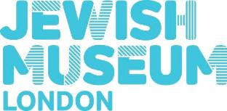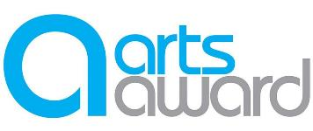

**Arts Award Discover Logbook**

**Full Name:**

**Email Address to send the certificate to:**

**There are four parts to this logbook. Discover the Arts, Part A – Take part, Part B – Find out More and Part C – Share. You will need to fill in every section to finish the logbook. For ideas about how to do each section visit our website. When you have finished this logbook please email it to: learning@jewishmuseum.org.uk**

For Arts Award Discover’s Equal Opportunity Monitoring it would be helpful to have the below information. Please feel free to leave any section blank.

**Date of Birth:**

**Gender:**

**Ethnicity:**

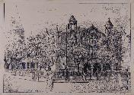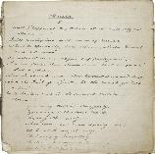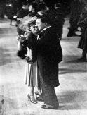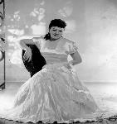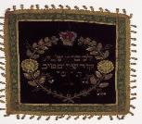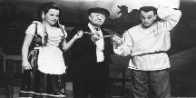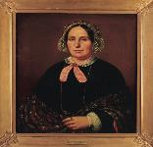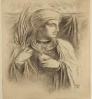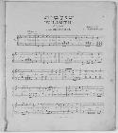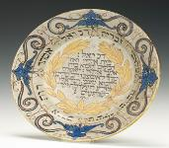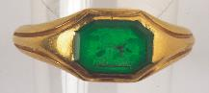

**Textiles**

**Music**

**Discover the Arts**

**Circle any arts that you have seen in your home or local area. Perhaps you have even taken part in some of these.**

**Painting**

**Pottery**

**Drama**

**Literature**

**Architecture**

**Jewellery**

**Dance**

**Drawing**

**Photography**

**Part A– Take Part**

**Have a go at an activity– look on our website for some ideas.**

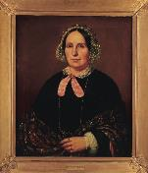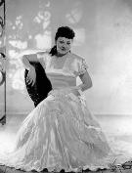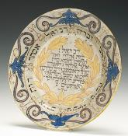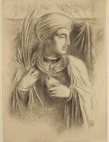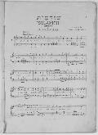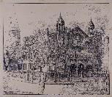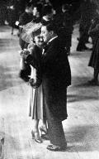

**What were your three favourite things about the activity?**

**What activity did you take part in?**

**Part B– Find Out More**

**What can you find out about your chosen artist?**

**1) Which artist have you chosen?**

**2) What type of art do they do? E.g. dancing, painting, pottery**

**3) If you could ask your artist 3 questions, what would you ask?**

**4) What skills, methods, materials do they use?**

**Part C– Share**

**Share what you have found out and what activity you took part in. You could speak to a family member or send a photo of your activity to a friend.**

**What have you shared?**

**How did you share it?**

**Who did you share it with?**

