Jewish Lives: Six-part book series launches to recognise the lives of remarkable British Jews

www.jewishlivesproject.com / www.jewishmuseum.org.uk / @jewishmuseumLDN

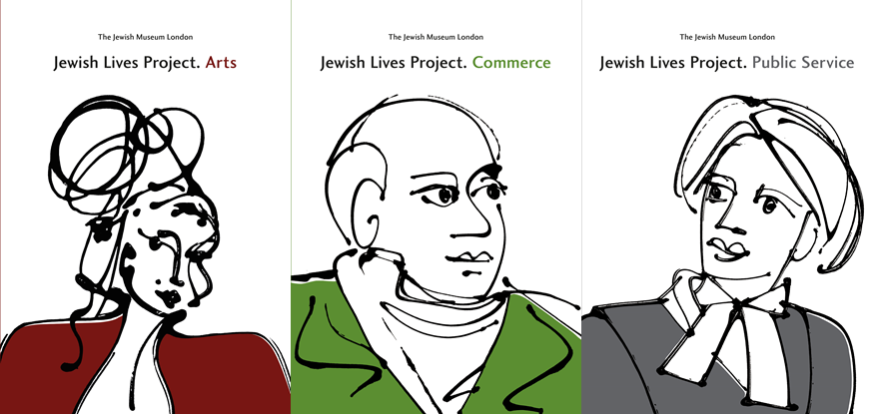

London, 24 May 2018 – Jewish Lives is a new project telling the stories of the remarkable Jewish men and women who helped to shape British society. Led by Jewish Museum London with the support of the Kirsh Charitable Foundation, the project takes the form of a six-part book series, an interactive digital platform, and a visual display at the Jewish Museum London. Each book will focus on the contributions of individual Jews to a different sector, including arts, public service and commerce.

Jewish Lives launches on Thursday 24th May with the publication of the first three volumes – Arts, Public Service, and Commerce – of the six-part series. Following the first three editions, a further three books will be published, focusing on Thought, Science, and Sport.

Jewish Lives. Arts focuses on the huge contribution of over 250 Jewish figures to arts and entertainment, and includes biographies of artists, photographers, actors, directors, broadcasters, comedians, musicians, writers, songwriters and performers.

Featured artists include:
- Gerry Anderson, pioneering puppeteer who created the Thunderbirds, Captain Scarlet and more
- Ruth Prawer Jhabvala, writer, the only person to have won both the Booker Prize and an Oscar for writing
- Lucian Freud, painter
- Peter Sellers, actor and flawed comic genius
- Amy Winehouse, singer and songwriter

Authored essays in the book include Marina Fiorato on female Jewish writers, Nathan Abrams on Jews in pop culture, Naomi Games on design, Julia Weiner on art and Jo Kerr on architecture.

Jewish Lives. Public Service explores the contribution of Jews to British public life, be it as philanthropists, soldiers, lawyers, politicians on all sides of the house, suffragists who campaigned for women’s’ voting rights, or SOE agents who risked their lives during the Second World War.

Featured public servants include:
- Rose Heilbron, Britain’s first female judge
- Sir Hersch Lauterpacht, a lawyer who developed the concept of crimes against humanity
- Krystyna Skarbeck, SOE agent honoured with OBE, George Medal and Croix de Guerre
- Lenora Cohen, suffragette and bodyguard to Emmeline Pankhurst
- Lionel de Rothschild, first practising Jew to sit as a member of parliament

Authored essays in the book include Daniel Finkelstein on political pioneers, Prof William D Rubinstein on Jews and the legal profession, and on Jewish philanthropists, Clare Mulley on Jewish female SOE Agents of WWII, and Roz Currie on Jewish women and the fight for the vote.

Jewish Lives. Commerce looks at the extraordinary contribution of British Jews to the commercial sector, and includes biographies of bankers, business men and women, financiers, hoteliers, publishers, industrialists and manufacturers.

Figures featured in this edition include:
- Brian Epstein, legendary manager of the Beatles
- Rachel Beer, the first woman to edit a Fleet Street newspaper
- Jack Cohen, retailer who founded Tesco
- Nathan Mayer Rothschild, founder of the famous banking dynasty
- Joseph Lyons, pioneer of mass catering and creator of ‘Lyons Corner Shops’

Authored essays in the book include Professor William Rubinstein on Jewish banking, Nathan Abrams on the entertainment industry, Elizabeth Selby and Emmanuelle Dirix on different aspects of high street retailing and Derek Taylor on the crucial role played by Jewish financiers in supporting Britain’s military campaigns.

To accompany the release of the books, Jewish Museum London also launches an interactive digital platform (www.JewishLivesProject.com) telling the story of all the men and women covered in the books, alongside many others. Members of the public will be invited to nominate further Jewish lives for inclusion.

Abigail Morris, Director of Jewish Museum London, said: “In considering the extraordinary contribution of British Jews to the fields of culture, public service and commerce, we are not only celebrating individual Jewish lives but exploring specific Jewish values.

“For example, the importance placed on questioning in Judaism can lead to a proliferation of artists as much as of lawyers. Similarly, the concept of tikkun olam – or, healing the world – which draws Jews to engage in material culture, is as close to business leadership as it is to charity and politics.

“We look forward to further input from the public via the Jewish Lives digital platform, and continuing to enrich the living memory of people who have helped shape Britain, and indeed the world.”

Jewish Lives is published by Jewish Museum London. Each issue is priced £25, available to purchase in shops around the country or online. More information is available at www.JewishLivesProject.com

ENDS

Press contact:
jewishmuseum@brunswickgroup.com
+44 (0) 207 343 8180

VISITOR INFORMATION:

Website: jewishmuseum.org.uk
Twitter: @jewishmuseumLDN
Instagram: @jewishmuseumLDN
Facebook: facebook.com/jewishmuseumLDN

Address: Jewish Museum London
Raymond Burton House
129 – 131 Albert Street
London NW1 7NB

Tube: Camden Town
Opening Times: Daily 10am – 5pm (Friday: 10am – 2pm)

Museum admission (includes entry to exhibition and all permanent displays)
Adults - £8.50*
Concessions - £6.50*
Children (5-16) - £3.50
Under 5s – free
Family ticket (two adults and up to four children) - £18

* Includes £1 voluntary donation

NOTES TO EDITORS:

About Jewish Museum London
Our mission at the Jewish Museum London is to surprise, delight and engage all people, irrespective of background and faith, in the history, identity and culture of Jews in Britain. Our exhibitions, events and learning programmes encourage a sense of discovery and aim to provoke questions, challenge prejudice, and encourage understanding.
http://jewishmuseum.org.uk/

